

**SMART WATER METER DATA ANALYZED TO WATER ISSUES**

**PROJECT REVIEW 1**

Adithyan.S CBENU4CSE22204

Hari Prasaath.S.B CBENU4CSE22221

Kabilan.M.D CBENU4CSE22227

Sai Krishna.K CBENU4CSE22246

Contents

Abstract 3

Functionalities 4

Drawbacks 4

Technology Stack 4

Project Modules 5

1. Homepage Module 5

2. Analytics for household Module 5

3. Street wise analysis Module 5

4. City wise analysis Module 5

5. Administrator Module 5

6. Complaint Module 6

ER Diagram 7

Schema 7

Schema Diagram 8

SQL queries 9

Creating Tables 9

Inserting Values 12

**ABSTRACT**

**Smart water meter** is an innovative device that measures, analyses, and communicates water-related data. Detecting inappropriate consumption of water.

*What are the loses of Traditional water meter:*

* Traditional water meters allowed water utilities to record the water consumed by a household or an industry and bill them accordingly.
* Incapable to fulfil the sustainable development policies made to reduce water wastage and contamination.
* This is due to unidentified losses in the form of water pipe leakages, frauds, and defective meters**.**

*Few uses and examples of Smart water meter:*

* Allowing remote location monitoring and infrastructure maintenance through leak detection.
* Enable automatic billing and customer management.
* Due to their battery-powered nature, smart water meters play an important role in system configuration.
* automatic sprinkler system can be used in sports fields and farms to keep the grass/crops fresh with the minimum usage of water.

**FUNCTIONALITIES**

* Monitor the flow, distribution, and consumption of water
* Improve access to clean and safe water
* Enable real-time or frequent access to water consumption information and billing
* Reduce manual water meter reading and cost
* Improve leak and fraud detection
* increases data collection accuracy

**DRAWBACKS**

* High deployment and maintenance costs
* Lack of sufficient infrastructure to support smart metering
* Lack of skills
* Interoperability issues
* Weak communication signals in some locations
* Power cabling challenges in confined and remote locations

**TECHNOLOGY STACK**

* Front-end: HTML, CSS, JavaScript (for creating the user interface web page)
* Database: mySQL Server & pgAdmin 4 (for storing and managing the collected data)

**MODULES:**

1. Homepage Module:

Description: The Homepage Module serves as the project's gateway, providing a visually engaging interface with essential smart water. It shows the types of smart water meters available in the market

Purpose: An overview what the website offers and the type of analysis we get.

2.Analytics for a household Module:

Description: The Analytics for a household module serves as the platform for an user to enter his household code and password thus making him to see his/her water usage and analysis of it comparing to previous months and the neighborhood average usage.

Purpose: This enables each and every citizen to be aware of his/her usage of water and prevent them from overusing and also identify if there is any leakage present.

3.Street-wise analysis Module

Description: The street wise analysis module presents the insights of the water usage of each and every street thus the city’s representatives can analyze the situation and act accordingly.

Purpose: Leakages can be found immediately and acted accordingly to prevent water wastage.

4.City-wise analysis Module

Description: The city wise analysis module presents the insights of the water usage of each and every thus the city’s representatives can analyze the situation and act accordingly.

Purpose: Leakages can be found immediately and acted accordingly to prevent water wastage.

5.Administrator Module

Description: This module offers the server members to access privileged and complete information for development purposes by entering their admin id and password. The city wise and street wise analytics can be viewed only by the admin.

Purpose: Development of the software can be done smoothly as there always scope for improvement.

6.Complaint Module

Description: This module offers the users for a platform to file complaints regarding any irregularities in data for their households or cities or any bugs/glitches in the website.

Purpose: This enables the administrators to fix bugs/glitches or any malfunctions effectively and quickly.

**ER DIAGRAM**

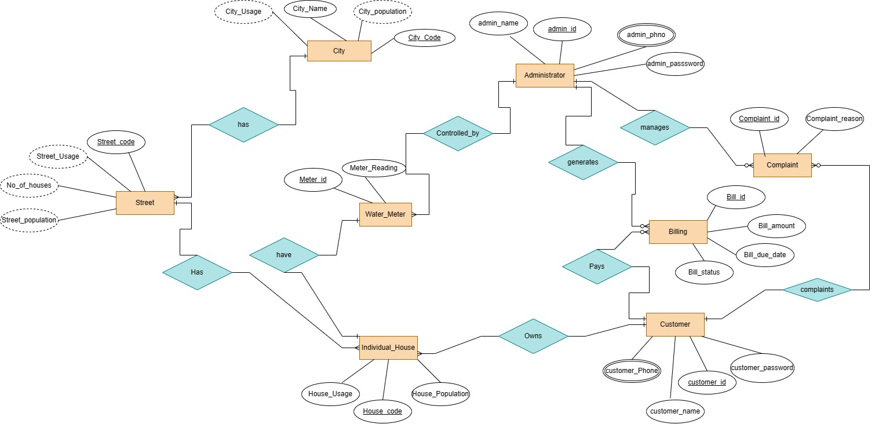

**RELATIONAL SCHEMA**

* Administrator(Admin_Id(pk),Admin_Name,Admin_Password(unique),Admin_Phone_Number)
* City(City_Code(pk),City_Name,City_Population,City_Usage)
* Complaint(Complaint_Id(pk),Complaint_Reason,Admin_id(fk))
* Customer(Customer_Id(pk),Customer_Name,Customer_Password(unique),Customer_Phone_Number,Complaint_Id(fk))
* Water_Meter(Meter_Id(pk),Meter_Reading,Admin_Id(fk))
* Street(Street_Code(pk),City_Code,Street_Population,Street_Usage,Number_of_House,City_Code(fk))
* Billing(Bill_Id(pk),Bill_Amount,Bill_Due_Date,Bill_Status,Admin_Id(fk),Cust_Id(fk))
* House(House_Code(pk),House_Population,House_Usage,Customer_Id(fk),Street_Code(fk),Meter_Id(fk))**SCHEMA DIAGRAM**

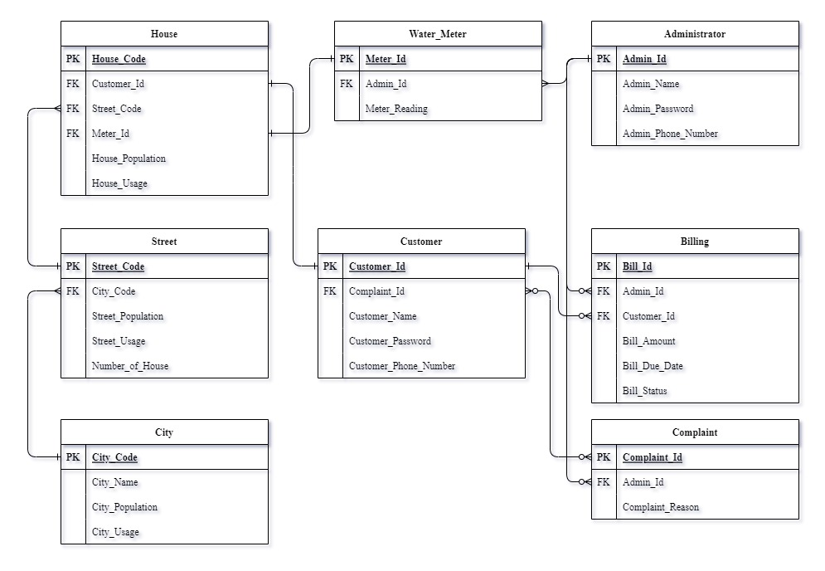

**SQL QUERIES**

**CREATING TABLES:**

CREATE TABLE Administrator (

Admin_Id INT PRIMARY KEY,

Admin_Name VARCHAR(100),

Admin_Password VARCHAR(50) UNIQUE,

Admin_Phone_Number VARCHAR(15)

);

CREATE TABLE City (

City_Code INT PRIMARY KEY,

City_Name VARCHAR(100),

City_Population BIGINT,

City_Usage BIGINT

);

CREATE TABLE Complaint (

Complaint_Id INT PRIMARY KEY,

Admin_Id INT,

Complaint_Reason VARCHAR(500),

FOREIGN KEY (Admin_Id) REFERENCES Administrator(Admin_Id)

);

CREATE TABLE Customer (

Customer_Id INT PRIMARY KEY,

Complaint_Id INT,

Customer_Name VARCHAR(100),

Customer_Password VARCHAR(50) UNIQUE,

Customer_Phone_Number VARCHAR(15),

FOREIGN KEY (Complaint_Id) REFERENCES Complaint(Complaint_Id)

);

CREATE TABLE Water_Meter (

Meter_Id INT PRIMARY KEY,

Admin_Id INT,

Meter_Reading BIGINT,

FOREIGN KEY (Admin_Id) REFERENCES Administrator(Admin_Id)

);

CREATE TABLE Street (

Street_Code INT PRIMARY KEY,

City_Code INT,

Street_Population BIGINT,

Street_Usage BIGINT,

Number_of_House BIGINT,

FOREIGN KEY (City_Code) REFERENCES City(City_Code)

);

CREATE TABLE Billing (

Bill_Id INT PRIMARY KEY,

Admin_Id INT,

Cust_Id INT,

Bill_Amount FLOAT,

Bill_Due_Date DATE,

Bill_status INT,

FOREIGN KEY (Admin_Id) REFERENCES Administrator(Admin_Id),

FOREIGN KEY (Cust_Id) REFERENCES Customer(Customer_Id)

);

CREATE TABLE House (

House_Code INT PRIMARY KEY,

Customer_Id INT,

Street_Code INT,

Meter_Id INT,

House_Population BIGINT,

House_Usage BIGINT,

FOREIGN KEY (Customer_Id) REFERENCES Customer(Customer_Id),

FOREIGN KEY (Street_Code) REFERENCES Street(Street_Code),

FOREIGN KEY (Meter_Id) REFERENCES Water_Meter(Meter_Id)

);

**INSERTING VALUES**

-- Administrator Table

INSERT INTO Administrator (Admin_Id, Admin_Name, Admin_Password, Admin_Phone_Number)

VALUES

(1, 'John Doe', 'password1', '555-1234'),

(2, 'Jane Smith', 'password2', '555-5678'),

(3, 'Bob Johnson', 'password3', '555-9876'),

(4, 'Mary Brown', 'password4', '555-4321'),

(5, 'David Davis', 'password5', '555-8765'),

(6, 'Sarah Lee', 'password6', '555-2345'),

(7, 'Michael Williams', 'password7', '555-7890'),

(8, 'Jessica Taylor', 'password8', '555-3456'),

(9, 'Kevin Clark', 'password9', '555-6543'),

(10, 'Laura Martin', 'password10', '555-2109');

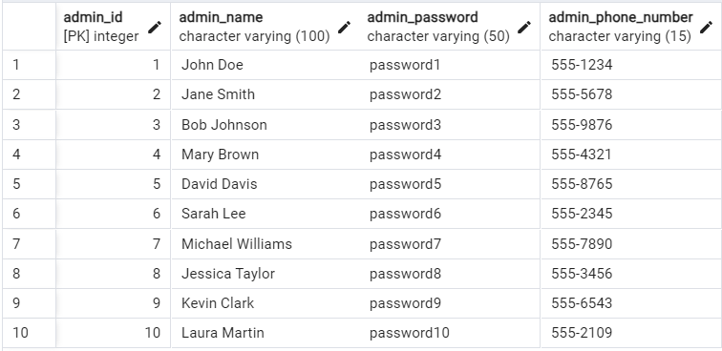

-- City Table

INSERT INTO City (City_Code, City_Name, City_Population, City_Usage)

VALUES

(1, 'New York', 8000000, 10000000),

(2, 'Los Angeles', 4000000, 6000000),

(3, 'Chicago', 2700000, 3500000),

(4, 'Houston', 2300000, 3000000),

(5, 'Phoenix', 1700000, 2200000),

(6, 'Philadelphia', 1600000, 2000000),

(7, 'San Antonio', 1500000, 1900000),

(8, 'San Diego', 1400000, 1800000),

(9, 'Dallas', 1300000, 1700000),

(10, 'San Francisco', 1200000, 1600000);

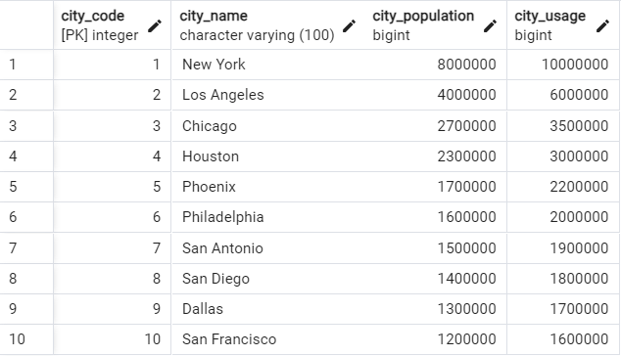

-- Complaint Table

INSERT INTO Complaint (Complaint_Id, Admin_Id, Complaint_Reason)

VALUES

(1, 1, 'Water Quality Issue'),

(2, 2, 'Billing Discrepancy'),

(3, 3, 'Meter Reading Error'),

(4, 4, 'Leakage Problem'),

(5, 5, 'Service Disruption'),

(6, 6, 'Infrastructure Maintenance'),

(7, 7, 'Billing Dispute'),

(8, 8, 'Low Water Pressure'),

(9, 9, 'Meter Replacement'),

(10, 10, 'Water Conservation Efforts');

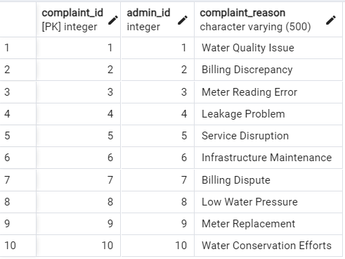

-- Customer Table

INSERT INTO Customer (Customer_Id, Complaint_Id, Customer_Name, Customer_Password, Customer_Phone_Number)

VALUES

(1, 1, 'Alice Johnson', 'pass123', '555-1111'),

(2, 2, 'Bob Smith', 'pass456', '555-2222'),

(3, 3, 'Charlie Davis', 'pass789', '555-3333'),

(4, 4, 'David Williams', 'passabc', '555-4444'),

(5, 5, 'Eve Brown', 'passdef', '555-5555'),

(6, 6, 'Frank Clark', 'passghi', '555-6666'),

(7, 7, 'Grace Martin', 'passjkl', '555-7777'),

(8, 8, 'Henry Taylor', 'passmno', '555-8888'),

(9, 9, 'Ivy Lee', 'passpqr', '555-9999'),

(10, 10, 'Jack Davis', 'passtu', '555-0000');

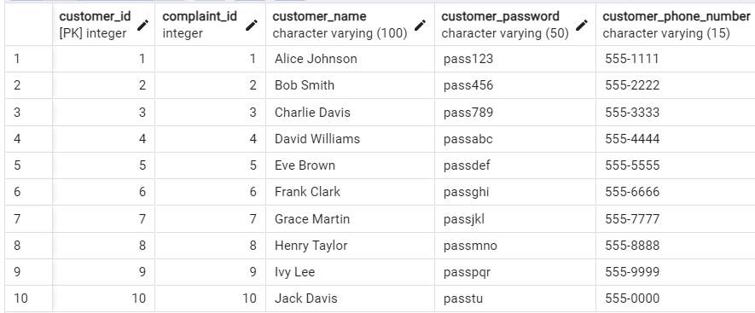

-- Water_Meter Table

INSERT INTO Water_Meter (Meter_Id, Admin_Id, Meter_Reading)

VALUES

(1, 1, 10000),

(2, 2, 11000),

(3, 3, 12000),

(4, 4, 13000),

(5, 5, 14000),

(6, 6, 15000),

(7, 7, 16000),

(8, 8, 17000),

(9, 9, 18000),

(10, 10, 19000);

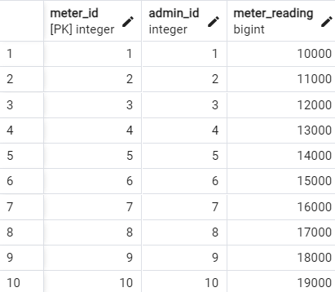

-- Street Table

INSERT INTO Street (Street_Code, City_Code, Street_Population, Street_Usage, Number_of_House)

VALUES

(1, 1, 5000, 6000, 1000),

(2, 2, 4000, 5000, 900),

(3, 3, 3000, 4000, 800),

(4, 4, 2000, 3000, 700),

(5, 5, 1000, 2000, 600),

(6, 6, 900, 1800, 500),

(7, 7, 800, 1600, 400),

(8, 8, 700, 1400, 300),

(9, 9, 600, 1200, 200),

(10, 10, 500, 1000, 100);

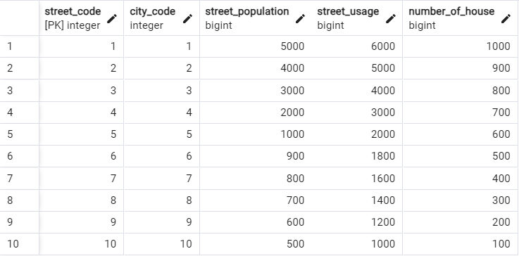

-- Billing Table

INSERT INTO Billing (Bill_Id, Admin_Id, Cust_Id, Bill_Amount, Bill_Due_Date,Bill_Status)

VALUES

(1, 1, 1, 50.25, '2023-10-01',0),

(2, 2, 2, 45.50, '2023-10-02',1),

(3, 3, 3, 55.75, '2023-10-03',1),

(4, 4, 4, 60.00, '2023-10-04',1),

(5, 5, 5, 40.75, '2023-10-05',0),

(6, 6, 6, 70.25, '2023-10-06',1),

(7, 7, 7, 75.50, '2023-10-07',1),

(8, 8, 8, 65.75, '2023-10-08',0),

(9, 9, 9, 80.00, '2023-10-09',0),

(10, 10, 10, 90.25, '2023-10-10',0);

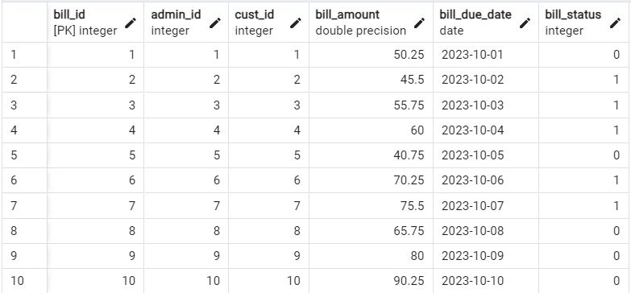

-- House Table

INSERT INTO House (House_Code, Customer_Id, Street_Code, Meter_Id, House_Population, House_Usage)

VALUES

(1, 1, 1, 1, 5, 10),

(2, 2, 2, 2, 4, 8),

(3, 3, 3, 3, 3, 6),

(4, 4, 4, 4, 2, 4),

(5, 5, 5, 5, 1, 2),

(6, 6, 6, 6, 4, 8),

(7, 7, 7, 7, 3, 6),

(8, 8, 8, 8, 2, 4),

(9, 9, 9, 9, 1, 2),

(10, 10, 10, 10, 5, 10);

